NANO-CATALYTIC DIRECT HYDROGENATION OF HETEROARENES
Introduction:
Catalytic hydrogenation of organic functional groups like carbonyl, alkene, alkyne, imine, nitro, etc. is vital in synthetic chemistry¹. In this respect, the direct hydrogenation of heteroarenes is particularly challenging owing to their high stability and the ability of the heteroatoms to deactivate catalysts². Nevertheless, hydrogenated heteroarenes form an essential component in fine chemicals, agrochemicals, pharmaceuticals, etc.

It is to be noted that quinolines form an important class of compound for accessing tetrahydroquinoline products that are widely used in drug molecules³. Usage of an active nano-catalytic system based on Rh on such reactions, however, could be much more versatile in terms of low catalyst poisoning, recyclability, reusability and higher activity than the traditionally used homogeneous pre-catalysts based on Ru, Rh, Ir etc. ⁴

Experimental:
Rhodium based nanoparticle system (monometallic and bimetallic variants) could be used to catalyse the hydrogenation of quinolines, pyridines and benzofurans to access the corresponding heterocycles [See the schemes in the figure below].
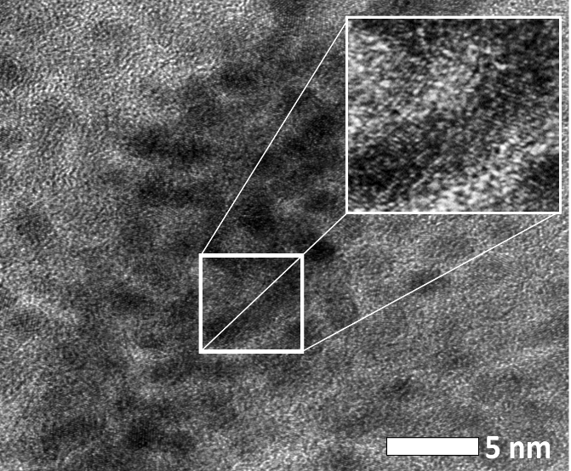  (a) | (b)
 | (c)
 | (d)
Figure 1(a) HR-TEM image of Rh NPs⁵; (b) scheme for hydrogenation of quinolines; (c) scheme for hydrogenation of benzofurans; (d) scheme for hydrogenation of pyridines.
An autoclave with a glass vessel would be used to conduct the hydrogenation reactions. The vessel would be then charged with the stock solution of Rh-based NPs in solvent and substrate prior to being pressurized with hydrogen gas to the desired pressure. The sealed autoclave would be then heated to the desired temperature and kept for the desired period of time.
Student objective:
To optimize the reaction conditions such as pressure, temperature, catalyst loading, and solvent selection; analysis of the products through GC-FID-MS; purification of the products by column chromatography; NMR and Mass spectroscopic analysis of purified products; report submission and presentation.
References:
- P. N. Rylander, Catalytic Hydrogenation in Organic Syntheses; Academic Press: 1979
- D. Wang, Q. Chen, S. Lu, Y. Zhou, Chem. Rev. 2012, 112, 2557.
- J. D. Keay, In Comprehensive Organic Synthesis; B.M. Trost, I. Fleming, Eds; Pergamon: Oxford, 1991; Vol. 8, pp 579-601.
- G. E. Dobereiner, A. Nova, N. D. Schley, N. Hazari, S. J. Miller, O. Eisenstein, R. H. Crabtree, J. Am. Chem Soc. 2011, 133, 7547.
- A. Karakulina, A. Gopakumar, I. Akçok, B. L. Roulier, T. La Grange, S. A. Katsyuba, S. Das, P. J. Dyson, Angew. Chem. Int. Ed. 2016, 55, 292-296

